**The problem**

To **identify all points falling within a maximum distance of xx meters with respect to each single point in a spatial points dataset**.

If you have a look at the thread, you will see that a simple solution based on creating a “buffered” polygon dataset beforehand and then intersecting it with the original points is quite fast ***for “reasonably sized” datasets***, thanks to sf spatial indexing capabilities which reduce the number of the required comparisons to be done In practice, something like this:

# create test data: 50000 uniformly distributed points on a "square" of 100000  
# metres  
maxdist <- 500  
pts <- data.frame(x = runif(50000, 0, 100000),  
 y = runif(50000, 0, 100000),  
 id = 1:50000) %>%  
 sf::st_as_sf(coords = c("x", "y"))  
# create buffered polygons  
pts_buf <- sf::st_buffer(pts, maxdist)  
# Find points within 500 meters wrt each point  
int <- sf::st_intersects(pts_buf, pts)  
int

## Sparse geometry binary predicate list of length 50000, where the predicate was `intersects'  
## first 10 elements:  
## 1: 1, 11046, 21668, 25417  
## 2: 2, 8720, 12595, 23620, 26926, 27169, 39484  
## 3: 3, 11782, 20058, 27869, 33151, 47864  
## 4: 4, 35665, 45691  
## 5: 5, 37093, 37989  
## 6: 6, 31487  
## 7: 7, 38433, 42009, 45597, 49806  
## 8: 8, 12129, 31486  
## 9: 9, 27840, 35577, 36797, 40906  
## 10: 10, 15482, 16615, 26103, 41417

However, this starts to have **problems over really large datasets**, because the total number of comparisons to be done still rapidly increase besides the use of spatial indexes. A **test** done by changing the number of points in the above example in the range 25000 – 475000 shows for example this kind of behavior, for two different values of maxdist (500 and 2000 m):

[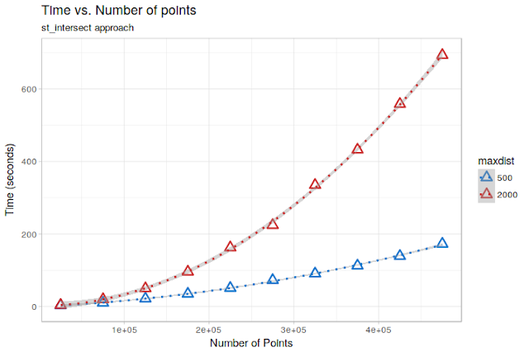](https://i2.wp.com/1.bp.blogspot.com/-KcqMy6mXBOo/WowAzjEyJSI/AAAAAAAANGE/_1-YSdF0gSgkAFwOg3hg0BqYUjMGTbWUACLcBGAs/s1600/Rplot01.png?ssl=1)

On the test dataset, the relationships are *almost perfectly quadratic* (due to the uniform distribution of points). Extrapolating them to the **12 Million points dataset of the OP**, we would get an execution time of about 14 hours for maxdist = 500, and a staggering **3.5 days** formaxdist = 2000. Still doable, but not ideal…

My suggestion to the OP was therefore to **“split” the points in chunks** based on the x-coordinate and then work on a per-split basis, eventually assigning each chunk to a different core within a parallellized cycle.

In the end, I got curious and decided to give it a go **to see what kind of performance improvement it was possible to obtain** with that kind of approach. You can find results of some tests below.

**A (possible) solution: Speeding up computation by combining data.table and sf_intersect**

**The idea here is to use a simple divide-and-conquer approach.**

**We first split the total spatial extent of the dataset in a certain number of regular quadrants. We then iterate over the quadrants and for each one we:**

1. **Extract the points contained into the quadrant and apply a buffer to them;**
2. **Extract the points contained in a slightly larger area, computed by expanding the quadrant by an amount equal to the *maximum distance for which we want to identify the “neighbors”;***
3. **Compute and save the intersection between the buffered points and the points contained in the “expanded” quadrant**

**“Graphically”, this translates to exploring the dataset like this:**

**[](https://i0.wp.com/1.bp.blogspot.com/-AG71hBW1vBw/Wov9Qxlo_8I/AAAAAAAANF4/OjpSHuc8Nx8vtRWiSSGHbgq_QCV8YraSQCLcBGAs/s1600/animation2.gif?ssl=1)**

**, where the points included in the current “quadrant” are shown in green and the additional points needed to perform the analysis for that quadrant are shown in red.**

**Provided that the subsetting operations do not introduce an excessive overhead (i.e., they are fast enough…) this should provide a performance boost, because it should consistently reduce the total number of comparisons to be done.**

**Now, every “R” expert will tell you that if you need to perform fast subsetting over large datasets the way to go is to use properly indexeddata.tables, which provide lightning-speed subsetting capabilities.**

**So, let’s see how we could code this in a functions:**

**points_in_distance <- function(in_pts,  
 maxdist,  
 ncuts = 10) {  
  
 require(data.table)  
 require(sf)  
 # convert points to data.table and create a unique identifier  
 pts <- data.table(in_pts)  
 pts <- pts[, or_id := 1:dim(in_pts)[1]]  
  
 # divide the extent in quadrants in ncuts*ncuts quadrants and assign each  
 # point to a quadrant, then create the index over "x" to speed-up  
 # the subsetting  
 range_x <- range(pts$x)  
 limits_x <-(range_x[1] + (0:ncuts)*(range_x[2] - range_x[1])/ncuts)  
 range_y <- range(pts$y)  
 limits_y <- range_y[1] + (0:ncuts)*(range_y[2] - range_y[1])/ncuts  
 pts[, `:=`(xcut = as.integer(cut(x, ncuts, labels = 1:ncuts)),  
 ycut = as.integer(cut(y, ncuts, labels = 1:ncuts)))] %>%  
 setkey(x)  
  
 results <- list()  
 count <- 0  
 # start cycling over quadrants  
 for (cutx in seq_len(ncuts)) {  
  
 # get the points included in a x-slice extended by `maxdist`, and build  
 # an index over y to speed-up subsetting in the inner cycle  
 min_x_comp <- ifelse(cutx == 1,  
 limits_x[cutx],  
 (limits_x[cutx] - maxdist))  
 max_x_comp <- ifelse(cutx == ncuts,  
 limits_x[cutx + 1],  
 (limits_x[cutx + 1] + maxdist))  
 subpts_x <- pts[x >= min_x_comp & x < max_x_comp] %>%  
 setkey(y)  
  
 for (cuty in seq_len(ncuts)) {  
 count <- count + 1  
  
 # subset over subpts_x to find the final set of points needed for the  
 # comparisons  
 min_y_comp <- ifelse(cuty == 1,  
 limits_y[cuty],  
 (limits_x[cuty] - maxdist))  
 max_y_comp <- ifelse(cuty == ncuts,  
 limits_x[cuty + 1],  
 (limits_x[cuty + 1] + maxdist))  
 subpts_comp <- subpts_x[y >= min_y_comp & y < max_y_comp]  
  
 # subset over subpts_comp to get the points included in a x/y chunk,  
 # which "neighbours" we want to find. Then buffer them by maxdist.  
 subpts_buf <- subpts_comp[ycut == cuty & xcut == cutx] %>%  
 sf::st_as_sf() %>%   
 sf::st_buffer(maxdist)  
  
 # retransform to sf since data.tables lost the geometric attrributes  
 subpts_comp <- sf::st_as_sf(subpts_comp)  
  
 # compute the intersection and save results in a element of "results".  
 # For each point, save its "or_id" and the "or_ids" of the points within "dist"  
 inters <- sf::st_intersects(subpts_buf, subpts_comp)  
  
 # save results  
 results[[count]] <- data.table(  
 id = subpts_buf$or_id,  
 int_ids = lapply(inters, FUN = function(x) subpts_comp$or_id[x]))  
 }  
 }  
 data.table::rbindlist(results)  
}**

**The function takes as input a points sf object, a target distance and a number of “cuts” to use to divide the extent in quadrants, and provides in output a data frame in which, for each original point, the “ids” of the points within maxdist are reported in the int_ids list column.**

Now, **let’s see if this works**:

**pts <- data.frame(x = runif(20000, 0, 100000),  
 y = runif(20000, 0, 100000),  
 id = 1:20000) %>%  
 st_as_sf(coords = c("x", "y"), remove = FALSE)  
maxdist <- 2000  
out <- points_in_distance(pts, maxdist = maxdist, ncut = 10)  
out**

**## id int_ids  
## 1: 15119 2054,18031, 9802, 8524, 4107, 7412,  
## 2: 14392 12213,10696, 6399,14392, 4610, 1200,  
## 3: 14675 2054,18031, 9802, 8524, 4107, 7412,  
## 4: 3089 12293,18031, 8524, 4107,12727, 2726,  
## 5: 17282 9802,8524,4107,7412,2726,1275,  
## ---   
## 19995: 248 16610, 7643, 8059,15998,16680, 1348,  
## 19996: 8433 16821,15638,16680, 3876,13851, 1348,  
## 19997: 17770 11060, 7643, 8059,19868, 7776,10146,  
## 19998: 11963 9948, 9136,15956,18512, 9219, 8925,  
## 19999: 15750 5291,18093,14462,15362,12575, 5189,**

**# get a random point  
sel_id <- sample(pts$id,1)  
pt_sel <- pts[sel_id, ]  
pt_buff <- pt_sel %>% sf::st_buffer(maxdist)  
# get ids of points within maxdist  
id_inters <- unlist(out[id == sel_id, ]$int_ids)  
pt_inters <- pts[id_inters,]  
  
#plot results  
ggplot(pt_buff) + theme_light() +  
 geom_point(data = pts, aes(x = x, y = y), size = 1) +  
 geom_sf(col = "blue", size = 1.2, fill = "transparent") +  
 geom_sf(data = pt_inters, col = "red", size = 1.5) +  
 geom_point(data = pt_sel, aes(x = x, y = y), size = 2, col = "green") +  
 xlim(st_bbox(pt_buff)[1] - maxdist, st_bbox(pt_buff)[3] + maxdist) +  
 ylim(st_bbox(pt_buff)[2] - maxdist, st_bbox(pt_buff)[4] + maxdist) +   
 ggtitle(paste0("id = ", sel_id, " - Number of points within distance = ", length(id_inters)))**

**[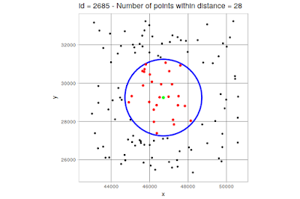](https://i1.wp.com/3.bp.blogspot.com/-S2NspQ46veo/WowBskp4_wI/AAAAAAAANGM/BdjMp99hg3QWexWxoPNo8xBLIpREsF5mACLcBGAs/s1600/Rplot2.png?ssl=1)**

**So far, so good. Now, let’s do the same exercise with varying number of points to see how it behaves in term of speed:**

**[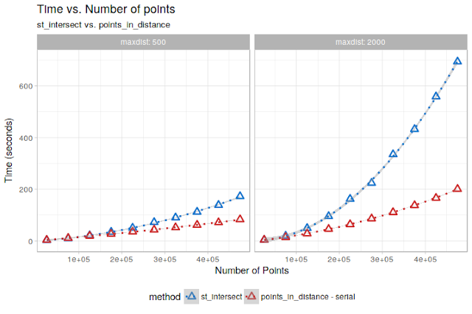](https://i2.wp.com/2.bp.blogspot.com/-jirwQtpYwuY/WowBureJrGI/AAAAAAAANGQ/bN94b1sanqg0KuWVtpn3USNPQjCmdC2ugCEwYBhgL/s1600/Rplot3.png?ssl=1)**

**Already not bad! In particular for the maxdist = 2000 case, we get a quite large speed improvement!**

**However, a nice thing about the points_in_distance approach is that it is easily parallelizable. All is needed is to change some lines of the function so that the outer loop over the x “chunks” exploits a parallel backend of some kind.**

**On a not-particularly-fast PC, using a 6-cores parallelization leads to this:**

**[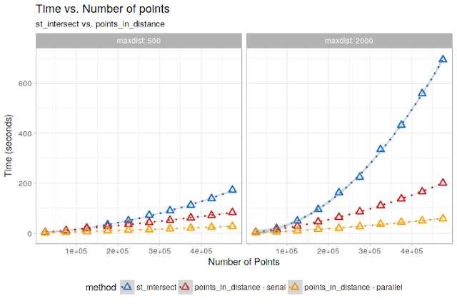](https://i1.wp.com/4.bp.blogspot.com/-PcjVQP4Yx_E/WowBzAV6vnI/AAAAAAAANGU/ZhXsCjd4RTgVRhksNymc3KU84m2xH0H4ACEwYBhgL/s1600/Rplot4.png?ssl=1)**

**Looking good! Some more skilled programmer could probably squeeze out even more speed from it by some additional data.table magic, but the improvement is very noticeable.**

**In terms of execution time, extrapolating again to the “infamous” 12 Million points dataset, this would be what we get:**

| Method | **Maxdist** | **Expected completion time (hours)** |
| --- | --- | --- |
| st_intersect | 500 | 15.00 |
| points_in_distance – serial | 500 | 2.50 |
| points_in_distance – parallel | 500 | 0.57 |
| st_intersect | 2000 | **85.00** |
| points_in_distance – serial | 2000 | 15.20 |
| points_in_distance – parallel | 2000 | **3.18** |

So, we get **a 5-6X speed improvement** already on the “serial” implementation, and **another 5X** thanks to parallelization over 6 cores! On themaxdist = 2000 case, this means going **from more than 3 days to about 3 hours**. And if we had more cores and RAM to throw at it, it would finish in minutes!

**Nice!**

**Final Notes**

* **The timings shown here are merely indicative, and related to the particular test-dataset we built. On a less uniformly distributed dataset I would expect a lower speed improvement.**
* Some time is “wasted” because **sf does not (yet) extend data.tables**, making it necessary to recreate sf objects from thedata.table subsets.
* The parallel implementation is quick-and-dirty, and it is a bit of a **memory-hog**! Be careful before throwing at it 25 processors!
* Speed is **influenced in a non-trivial way by the number of “cuts”** used to subdivide the spatial extent. There may be a sweet-spot related to points distribution and maxdist allowing reaching maximum speed.
* A similar approach for parallelization could exploit **repeatedly “cropping” the original sf points object** over the extent of the chunk/extended chunk. The data.table approach seems however to be faster.

Code Chunks of the Initial Analysis of the First Page : To **identify all points falling within a maximum distance of xx meters with respect to each single point in a spatial points dataset**.

What are the alternatives to this brute-force approach? Is it possible to build indexes using sf? Perhaps push the operation to an external database?

Reprex:

library(sf)

library(tidyverse)

library(parallel)

library(foreach)

# example data, convert to decimal:

nc <- st_read(system.file("shape/nc.shp", package="sf")) %>% st_transform(32618)

# expand the data a a bit to make the example more interesting:

nc <- rbind(nc,nc,nc)

nc <- nc %>% mutate(Id = row_number())

## can run in parallel if desired:

# num_cores <- parallel::detectCores()-2

# cl <- makeSOCKcluster(num_cores)

# registerDoSNOW(cl)

# or just run in sequence:

registerDoSEQ()

neighbors <- foreach(ii = 1:nrow(nc)

, .verbose = FALSE

, .errorhandling = "pass") %dopar% {

l = 500 # 500 meters

# isolate the row as the origin point:

row_interest <- filter(nc, row_number()==ii)

# create the buffer:

buffer <- row_interest %>% st_buffer(dist = l)

# extract the row numbers of the neighbors

comps_idx <- suppressMessages(st_intersects(buffer, nc))[[1]]

# get all the neighbors:

comps <- nc %>% filter(row_number() %in% comps_idx)

# remove the geometry:

comps <- comps %>% st_set_geometry(NULL)

# flow control in case there are no neibors:

if(nrow(comps)>0) {

comps$Origin_Key <- row_interest$Id

} else {

comps <- data_frame("lat" = NA_integer_,"lon" = NA_integer_, "bbl" = row_interest$bbl)

comps$Origin_Key <- row_interest$Id

}

return(comps)

}

closeAllConnections()

length(neighbors)==nrow(nc)

[1] TRUE

Let's see how it performs on a reasonably big dataset of 50000 points:

library(sf)

library(spdep)

library(sf)

pts <- data.frame(x = runif(50000, 0, 100000),

y = runif(50000, 0, 100000))

pts <- sf::st_as_sf(pts, coords = c("x", "y"), remove = F)

pts_buf <- sf::st_buffer(pts, 5000)

coords <- sf::st_coordinates(pts)

microbenchmark::microbenchmark(

sf_int = {int <- sf::st_intersects(pts_buf, pts)},

spdep = {x <- spdep::dnearneigh(coords, 0, 5000)}

, times = 1)

#> Unit: seconds

#> expr min lq mean median uq max neval

#> sf_int 21.56186 21.56186 21.56186 21.56186 21.56186 21.56186 1

#> spdep 108.89683 108.89683 108.89683 108.89683 108.89683 108.89683 1

You can see here that the st_intersects approach is 5 times faster than the dnearneigh one.

Unfortunately, this is unlikely to solve your problem. Looking at execution times for datasets of different sizes we get:

subs <- c(1000, 3000, 5000, 10000, 15000, 30000, 50000)

times <- NULL

for (sub in subs[1:7]) {

pts_sub <- pts[1:sub,]

buf_sub <- pts_buf[1:sub,]

t0 <- Sys.time()

int <- sf::st_intersects(buf_sub, pts_sub)

times <- cbind(times, as.numeric(difftime(Sys.time() , t0, units = "secs")))

}

plot(subs, times)

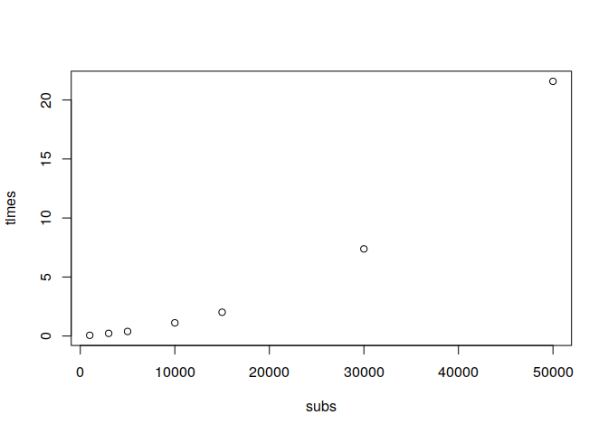

times <- as.numeric(times)

reg <- lm(times~subs+I(subs^2))

summary(reg)

#>

#> Call:

#> lm(formula = times ~ subs + I(subs^2))

#>

#> Residuals:

#> 1 2 3 4 5 6 7

#> -0.16680 -0.02686 0.03808 0.21431 0.10824 -0.23193 0.06496

#>

#> Coefficients:

#> Estimate Std. Error t value Pr(>|t|)

#> (Intercept) 2.429e-01 1.371e-01 1.772 0.151

#> subs -2.388e-05 1.717e-05 -1.391 0.237

#> I(subs^2) 8.986e-09 3.317e-10 27.087 1.1e-05 ***

#> ---

#> Signif. codes: 0 '***' 0.001 '**' 0.01 '*' 0.05 '.' 0.1 ' ' 1

#>

#> Residual standard error: 0.1908 on 4 degrees of freedom

#> Multiple R-squared: 0.9996, Adjusted R-squared: 0.9994

#> F-statistic: 5110 on 2 and 4 DF, p-value: 1.531e-07

Here, we see an almost perfect quadratic relationship between time and number of points (as would be expected). On a 10M points subset, assuming that the behaviour does not change, you would get:

predict(reg, newdata = data.frame(subs = 10E6))

#> 1

#> 898355.4

, which corresponds to about 10 days, assuming that the trend is constant when further increasing the number of points (but the same would happen for dnearneigh...)

My suggestion would be to "split" your points in chunks and then work on a per-split basis.

You could for example order your points at the beginning along the x-axis and then easily and quickly extract subsets of buffers and of points with which to compare them using data.table.

Clearly, the "points" buffer would need to be larger than that of "buffers" according to the comparison distance. So, for example, if you make a subset of pts_buf with centroids in [50000 - 55000], the corresponding subset of pts should include points in the range [49500 - 55500]. This approach is easily parallelizable by assigning the different subsets to different cores in a foreach or similar construct.

I do not even know if using spatial objects/operations is beneficial here, since once we have the coordinates all is needed is computing and subsetting euclidean distances: I suspect that a carefully coded brute force data.table-based approach could be also a feasible solution.

HTH!

**UPDATE**

In the end, I decided to give it a go and see how much speed we could gain from this kind of approach. Here is a possible implementation:

points_in_distance_parallel <- function(in_pts,

maxdist,

ncuts = 10) {

require(doParallel)

require(foreach)

require(data.table)

require(sf)

# convert points to data.table and create a unique identifier

pts <- data.table(in_pts)

pts <- pts[, or_id := 1:dim(in_pts)[1]]

# divide the extent in quadrants in ncuts*ncuts quadrants and assign each

# point to a quadrant, then create the index over "xcut"

range_x <- range(pts$x)

limits_x <-(range_x[1] + (0:ncuts)*(range_x[2] - range_x[1])/ncuts)

range_y <- range(pts$y)

limits_y <- range_y[1] + (0:ncuts)*(range_y[2] - range_y[1])/ncuts

pts[, `:=`(xcut = as.integer(cut(x, ncuts, labels = 1:ncuts)),

ycut = as.integer(cut(y, ncuts, labels = 1:ncuts)))] %>%

setkey(xcut, ycut)

results <- list()

cl <- parallel::makeCluster(parallel::detectCores() - 2, type =

ifelse(.Platform$OS.type != "windows", "FORK",

"PSOCK"))

doParallel::registerDoParallel(cl)

# start cycling over quadrants

out <- foreach(cutx = seq_len(ncuts)), .packages = c("sf", "data.table")) %dopar% {

count <- 0

# get the points included in a x-slice extended by `dist`, and build

# an index over y

min_x_comp <- ifelse(cutx == 1, limits_x[cutx], (limits_x[cutx] - maxdist))

max_x_comp <- ifelse(cutx == ncuts,

limits_x[cutx + 1],

(limits_x[cutx + 1] + maxdist))

subpts_x <- pts[x >= min_x_comp & x < max_x_comp] %>%

setkey(y)

for (cuty in seq_len(pts$ycut)) {

count <- count + 1

# subset over subpts_x to find the final set of points needed for the

# comparisons

min_y_comp <- ifelse(cuty == 1,

limits_y[cuty],

(limits_y[cuty] - maxdist))

max_y_comp <- ifelse(cuty == ncuts,

limits_y[cuty + 1],

(limits_y[cuty + 1] + maxdist))

subpts_comp <- subpts_x[y >= min_y_comp & y < max_y_comp]

# subset over subpts_comp to get the points included in a x/y chunk,

# which "neighbours" we want to find. Then buffer them.

subpts_buf <- subpts_comp[ycut == cuty & xcut == cutx] %>%

sf::st_as_sf() %>%

st_buffer(maxdist)

# retransform to sf since data.tables lost the geometric attrributes

subpts_comp <- sf::st_as_sf(subpts_comp)

# compute the intersection and save results in a element of "results".

# For each point, save its "or_id" and the "or_ids" of the points within "dist"

inters <- sf::st_intersects(subpts_buf, subpts_comp)

# save results

results[[count]] <- data.table(

id = subpts_buf$or_id,

int_ids = lapply(inters, FUN = function(x) subpts_comp$or_id[x]))

}

return(data.table::rbindlist(results))

}

parallel::stopCluster(cl)

data.table::rbindlist(out)

}

The function takes as input a **points sf object**, a **target distance** and a **number of "cuts"** to use to divide the extent in quadrants, and provides in output a data frame in which, for each original point, the "ids" of the points within maxdist are reported **in the int_ids list column**.

On on a test dataset with a varying number of uniformly distributed point, and two values of maxdist I got these kind of results (the "parallel" run is done using 6 cores):

[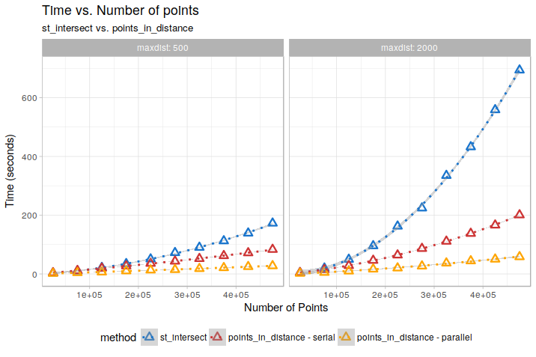](https://i.stack.imgur.com/Utck1.png)

So, here we get **a 5-6X speed improvement** already on the "serial" implementation, and **another 5X** thanks to parallelization over 6 cores. Although the timings shown here are merely indicative, and related to the particular test-dataset we built (on a less uniformly distributed dataset I wouldexpect a lower speed improvement) I think this is quite good.